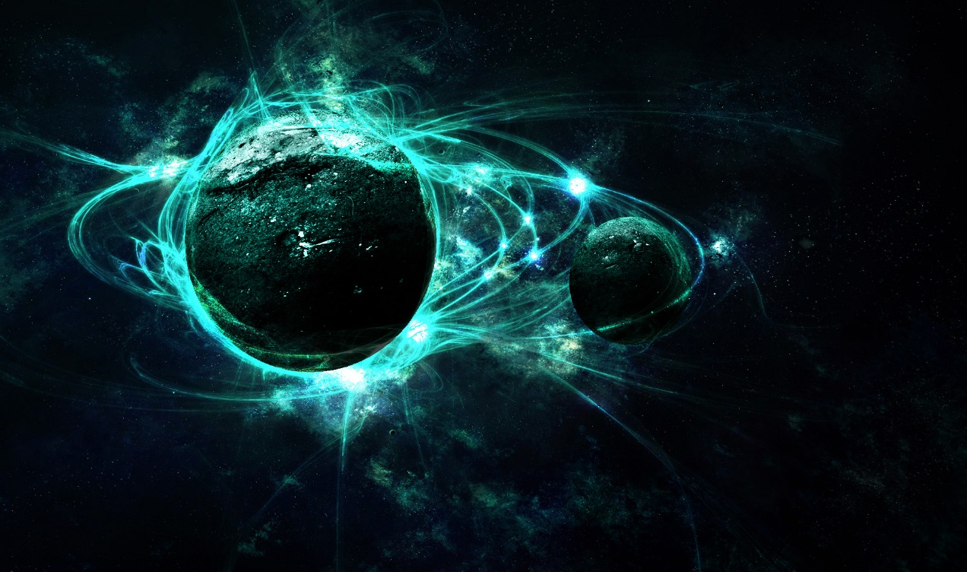

Welcome to planet Legion .It is between Mars and Jupiter .Come and see one of our legendary meteor showers that happens every night. Legion has two seasons, one really warm season and one really cold. So there is something for everyone! .It takes 30 minutes to get there. A day lasts 18 hours and a year lasts 6 months, so you can have two birthdays and two Christmases’ twice as quick as on Earth!! Legion is a great place to visit. There are lots of different animals and the nature is stunning. We are looking forward to seeing you and hope you will love it as much as we do.

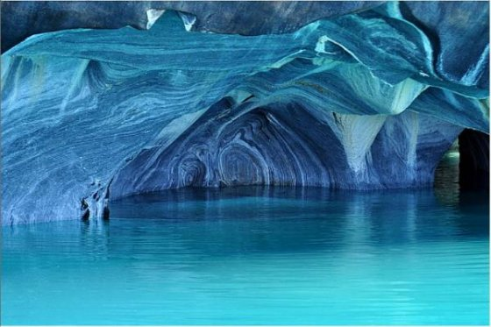lex

Come and swim in our beautiful, peaceful ice caves.

“It would be wonderful to explore the unknown.” Mrs Mabbott

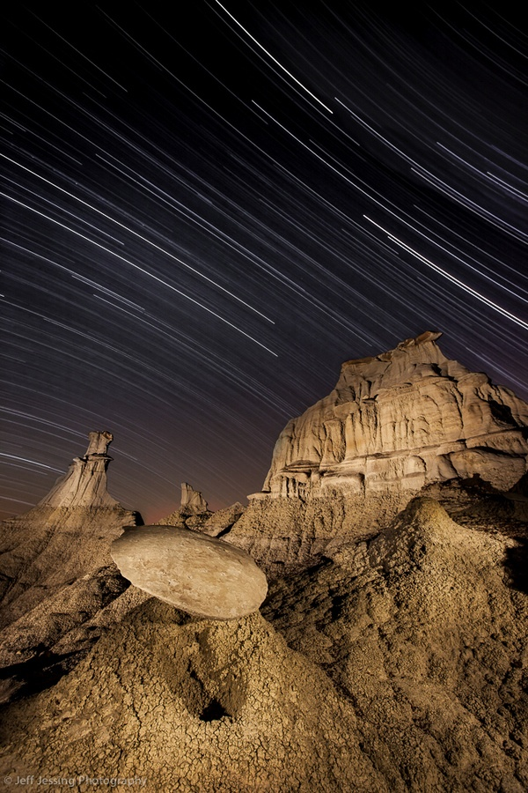

Watch the beautiful comets shooting through the Legion atmosphere

“I would love to know what is out there!” Mrs Williamson.

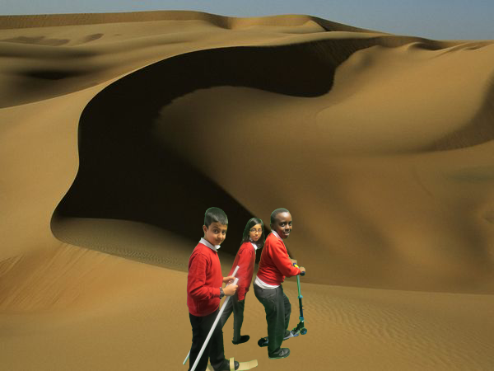

Glide elegantly through the textured sand dunes on your sand mobile.

“I would love to glide through the solar system planet by planet” Tumelo

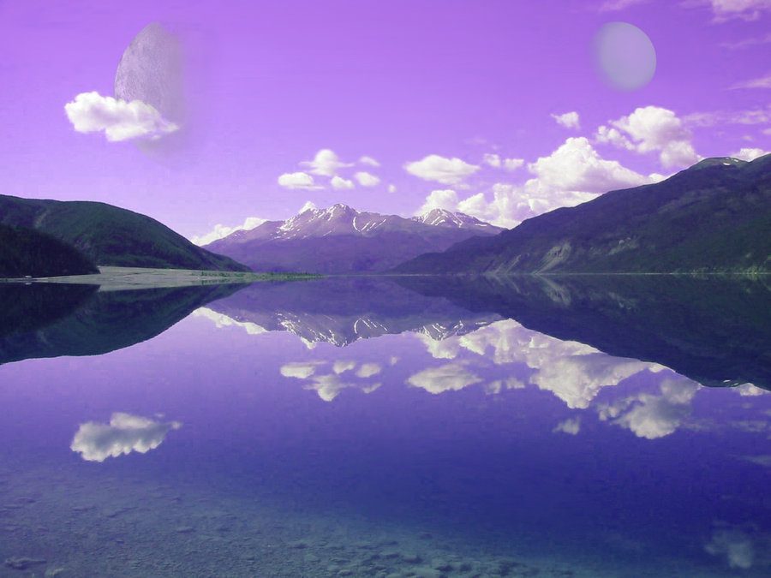

Surf along the reflective, sparkling water on your very own wonderful, water mobile!

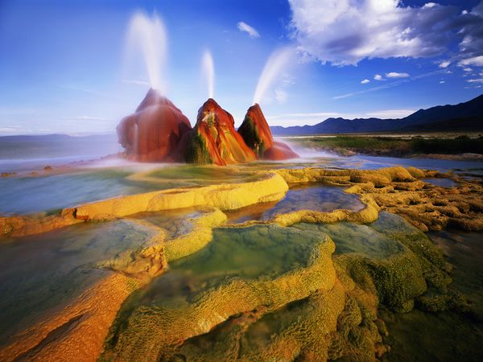

Have a splash in the wonderful multicoloured water fountains.

“I think watching the water fountain would be amazing” Laiba

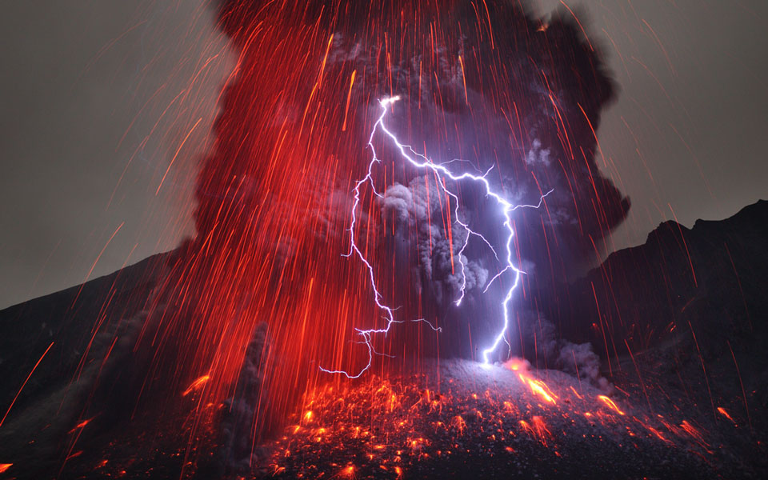

See the the electrical explosions as they erupt from the discharging volcanoes.

You will never get eliminated.”It will be beautiful to see the lights of the volcano.” Nafis