**Welcome to Galactica, out of this**

**World!**

**We have amazing things to see and do.**

**We have phenomenal places for children and adults. Why not come**

**and play zero-gravity football. Would you like to have a romantic night? Welcome to our breath taking planet. We have incredible restaurants.**

**ILOUMINOUS!**

**We have all the thing you couldn’t imagine doing! So come on - it is extraordinary at ILOUMINOUS!**

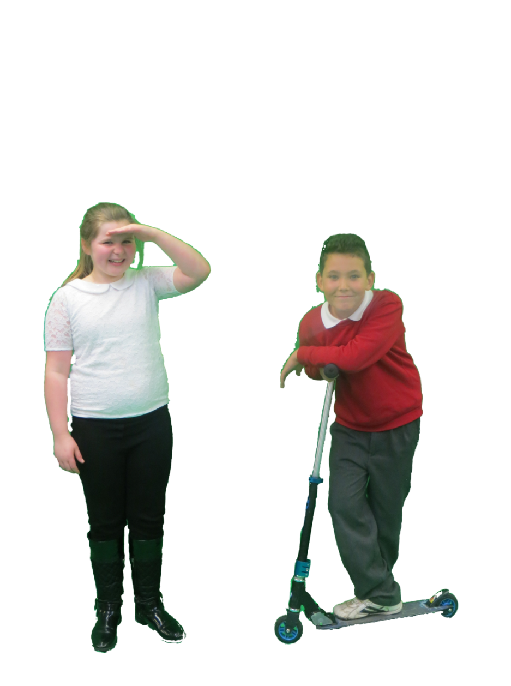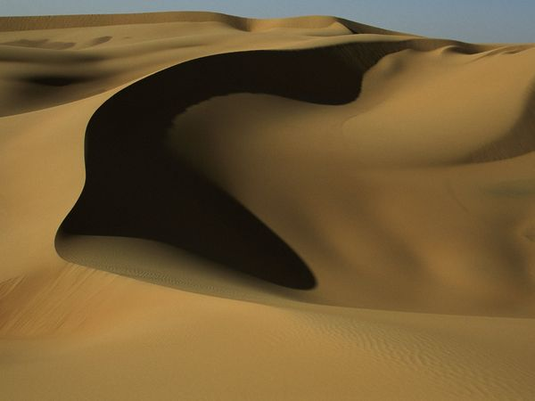

**Come to the sensational space scooting and scenery.**

**‘’It looks great and there is nowhere like it ‘’Mr Hollis.**

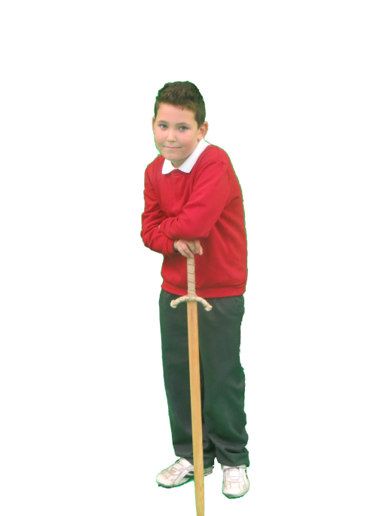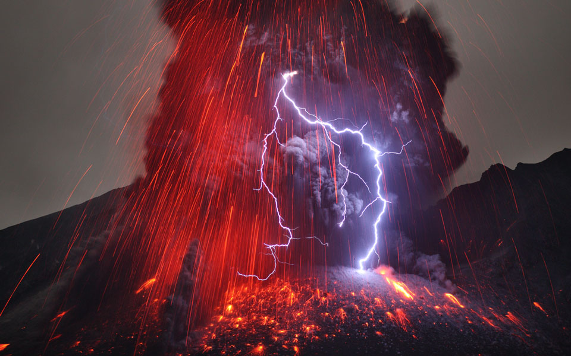

**Come to see and learn with the master who is burning Ben. Learn lighting sword fighting and discover the volcano’s treasure.**

**‘’Look at the amazing, lightning, lava volcano.**

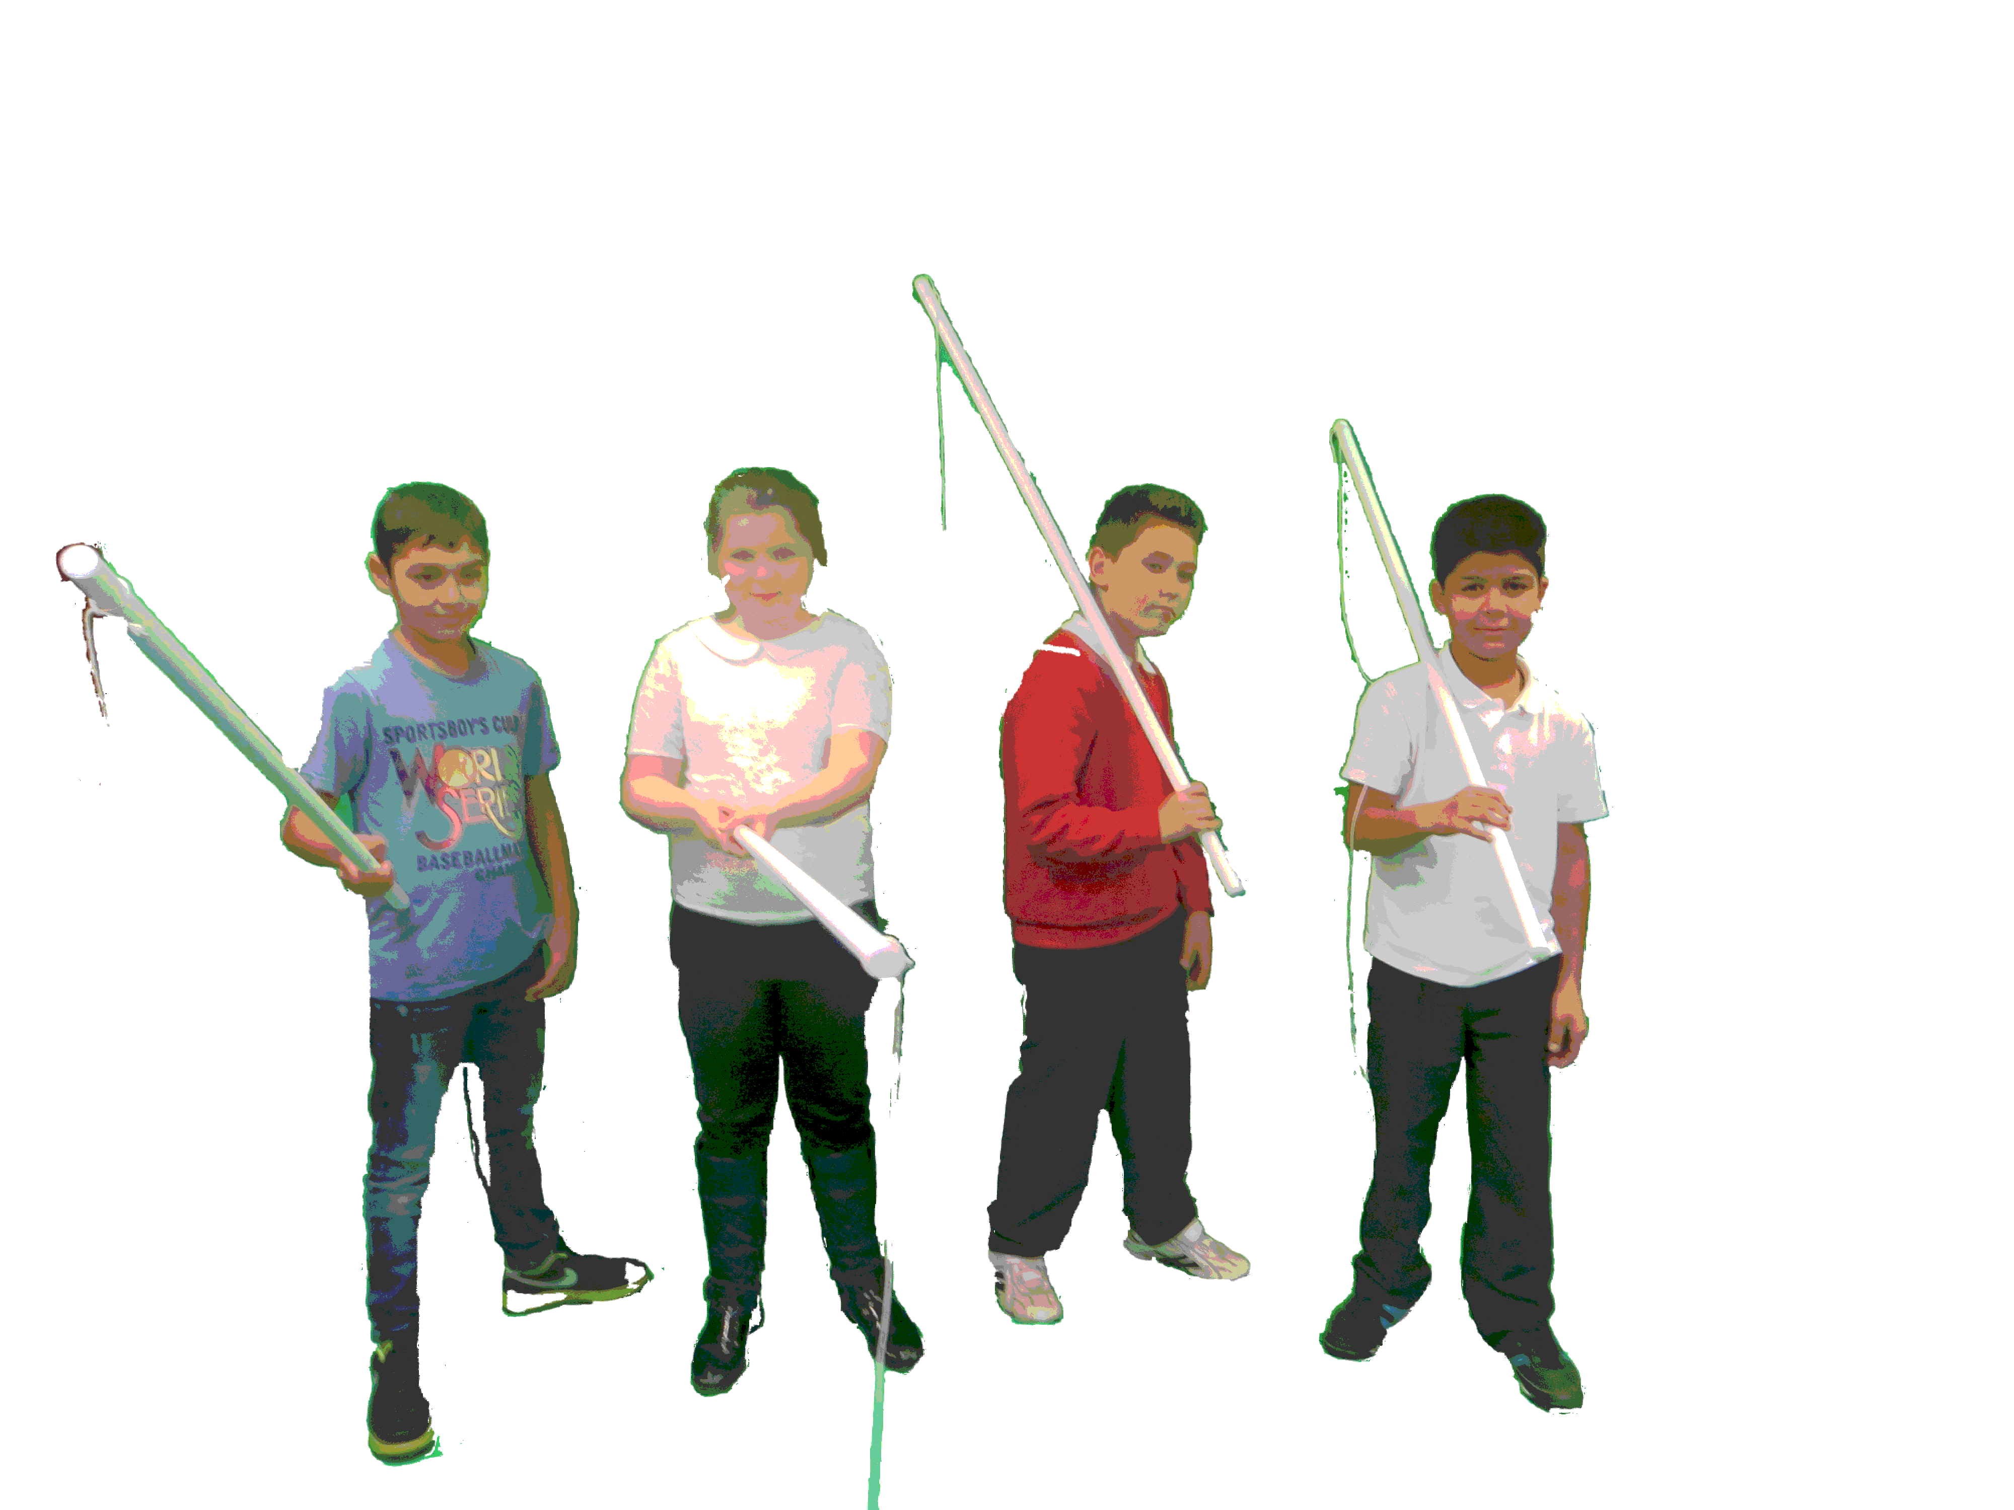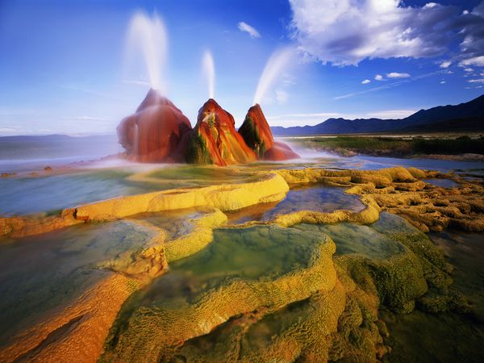[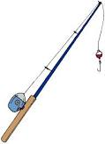](http://www.google.co.uk/imgres?q=fishing+rod&um=1&safe=active&biw=1366&bih=616&noj=1&hl=en&tbm=isch&tbnid=hCIH8SdQL2WK5M:&imgrefurl=http://fishingtipsandtechniquesforbeginners.com/fishing/fishing-with-rod/&docid=xodyJDh7nuoTMM&imgurl=http://lunar.thegamez.net/fishing/fishing-with-rod/fishing-with-rod-trout-fishing-headquarters-750x1038.jpg&w=750&h=1038&ei=_NaNUrefNMSv7AaAh4GgBg&zoom=1&iact=rc&dur=765&page=1&tbnh=131&tbnw=95&start=0&ndsp=26&ved=1t:429,r:2,s:0,i:89&tx=62&ty=88)

**Do you like fishing? Well if you do then why not come to the fishing, water, Volcano Park. There are brilliant tropical fish and water volcanoes. Explore all of them, while you’re in there you can visit our one and only gift shop.**

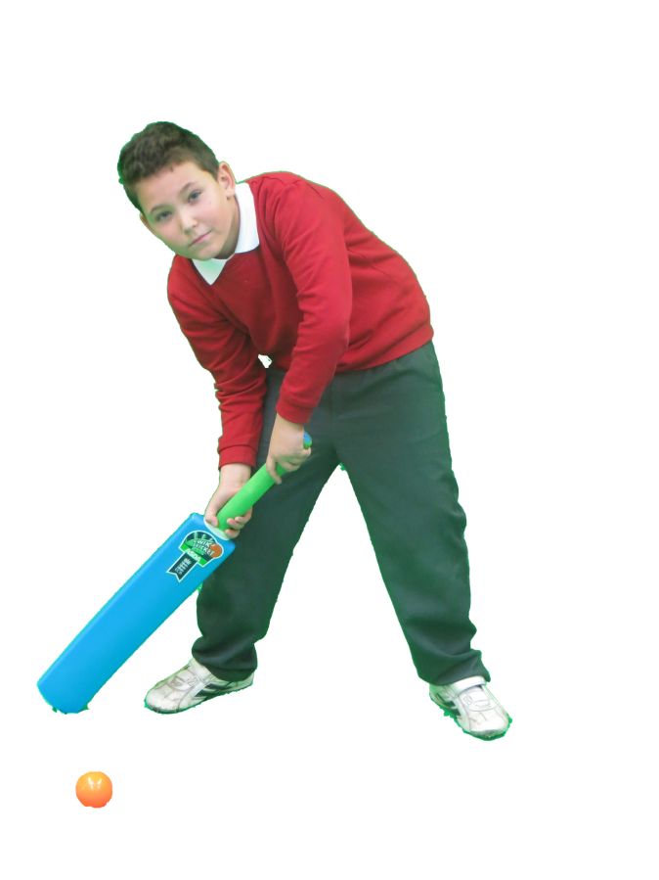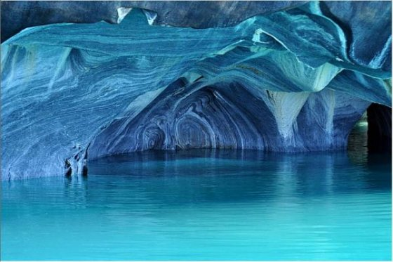

**Come to ice cricket where the one and only fabulous Ben will teach you everything you need to know all about it.**

**‘ I would love to come and learn ice cricket WOW ‘said Mrs Houlgate WOW!**

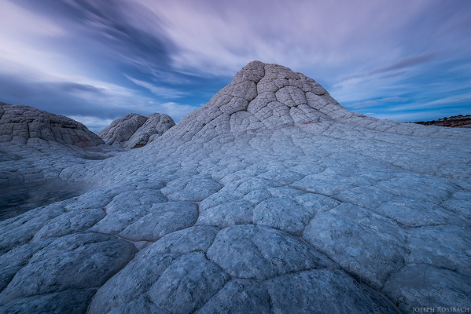

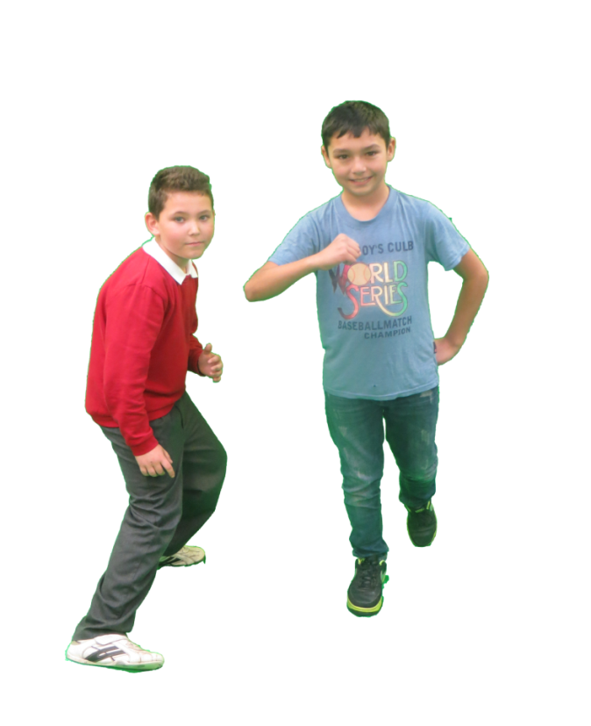

**Do you like football? Well if you do then come and play zero-gravity football, with Ben and Ionuts they will teach you. Join the fantastic club it’s great.**