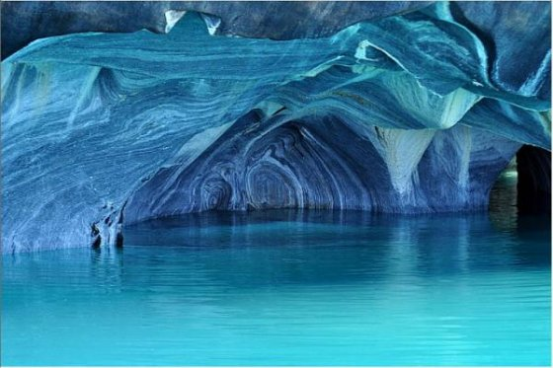hh

Amazing Blizzard Ball

Welcome to Sonic Boom Ball where your dreams become reality. Do life defying sports like gravity diving and typhoon bmxing. Here you can explore our planet blizzard ball. Cosmic gems give you POWERS!!!!! And COSMIC BORDS tickets cost 10p call 0123456789 or come to:

[www.sonic boomball.cosmic.com](http://www.scotholme.com/year-5-blog.html)

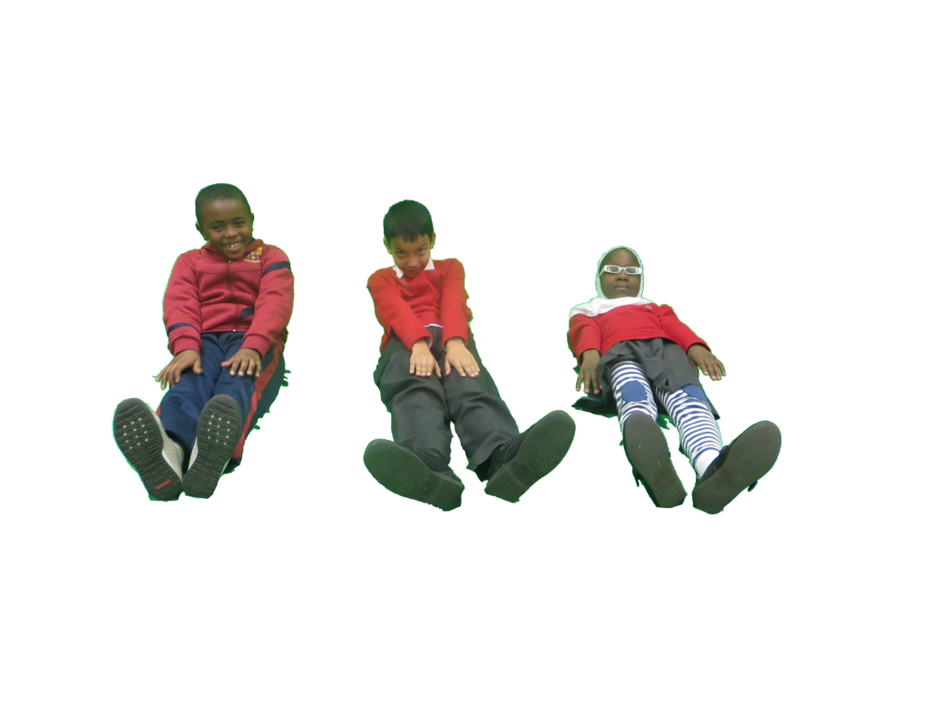ings

“Finally we have reach*ed our dreams” Daniyal Khan.*

*See this sensational ice cave. Wander through* your dreams .DON’T WAIT! COME ON!

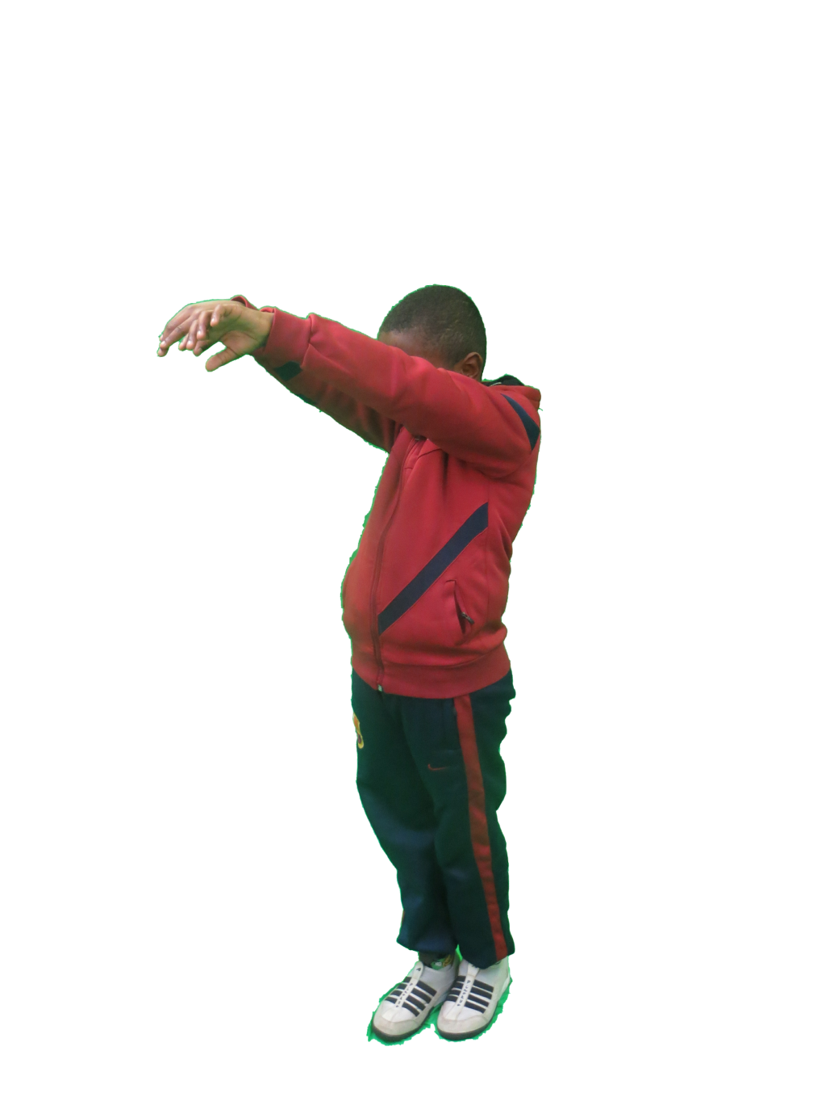

“WOW” gravity diving is amazing.

Go diving off the edge of the universe and let gravity pull you back up.

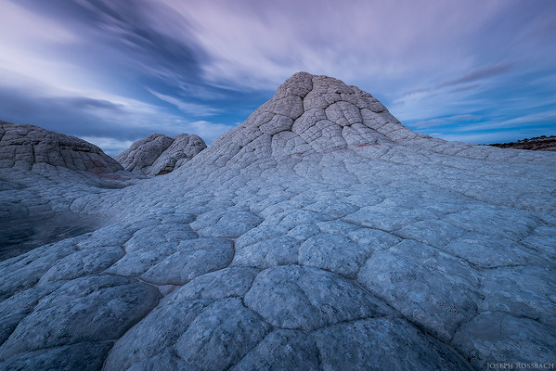v

“WOW there are lots of rocks”

This rocky surface is a perfect place for a nice view.

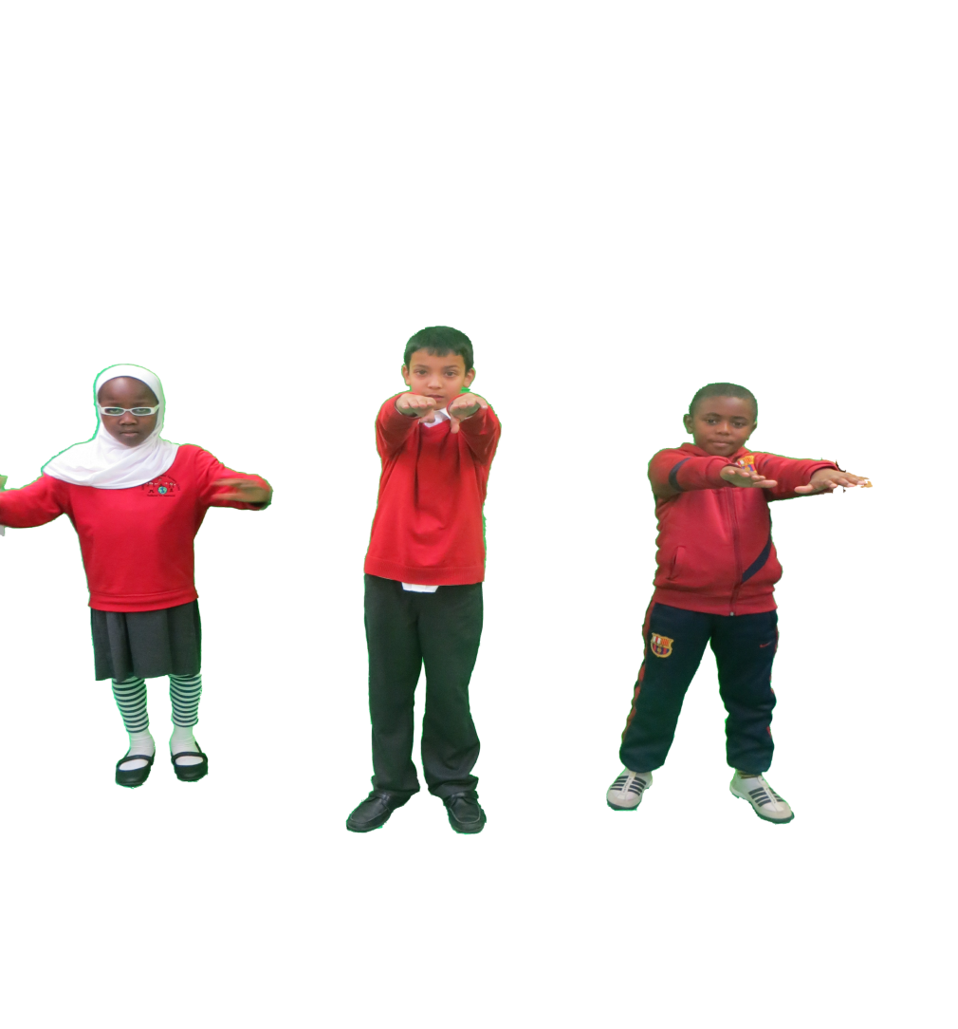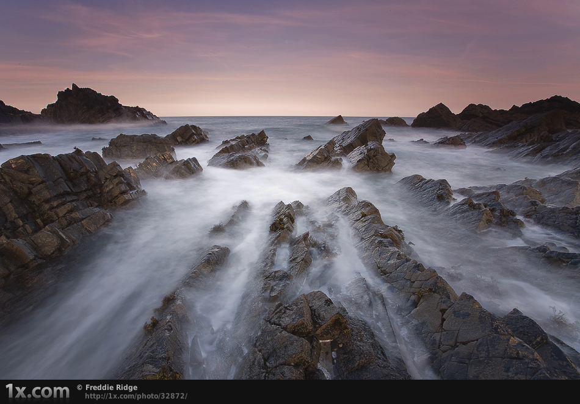a

“Its gobsmackingly brilliant”

Boost your stamina with this magical place formed by devious Daniyal, jolly Jor-el, amazing Abdul and magical Maryam.

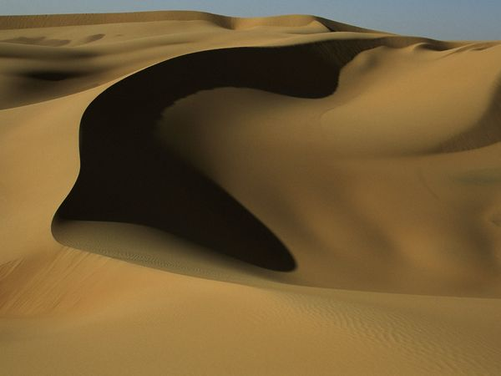+

This sandy desert is a soft area. You can do acrobatics and slip, slide and jump all over the place.