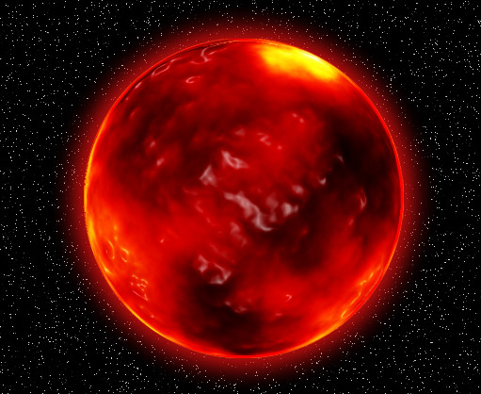M

Come to our planet Krypton , a land of contrasting environments! You can see lagoons, which are crystal green with floating pearls, surrounded by vibrant coral reefs.

We have rocky shorelines where you can mine your very own crystals and diamonds. If you want to become a millionaire, hop on to the next Aircraft! We have rainforests, volcanoes, hills, mountains and ice caves too! We have humid and hot weather for seven months and misty, cold weather for the next seven months. We have animals, which are extinct on earth like Dodos and dinosaurs. You will see biologists that are researching! If you’re a farmer, don’t worry! Our soil is very fertile and we have rainfalls too! We look forward to seeing you!

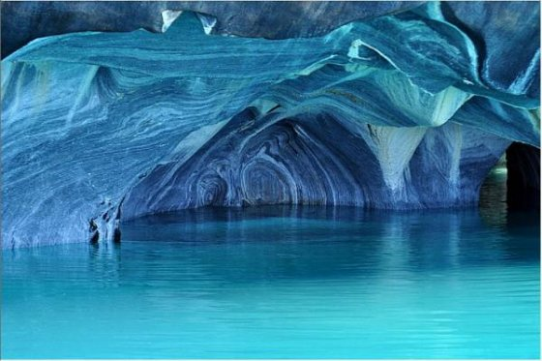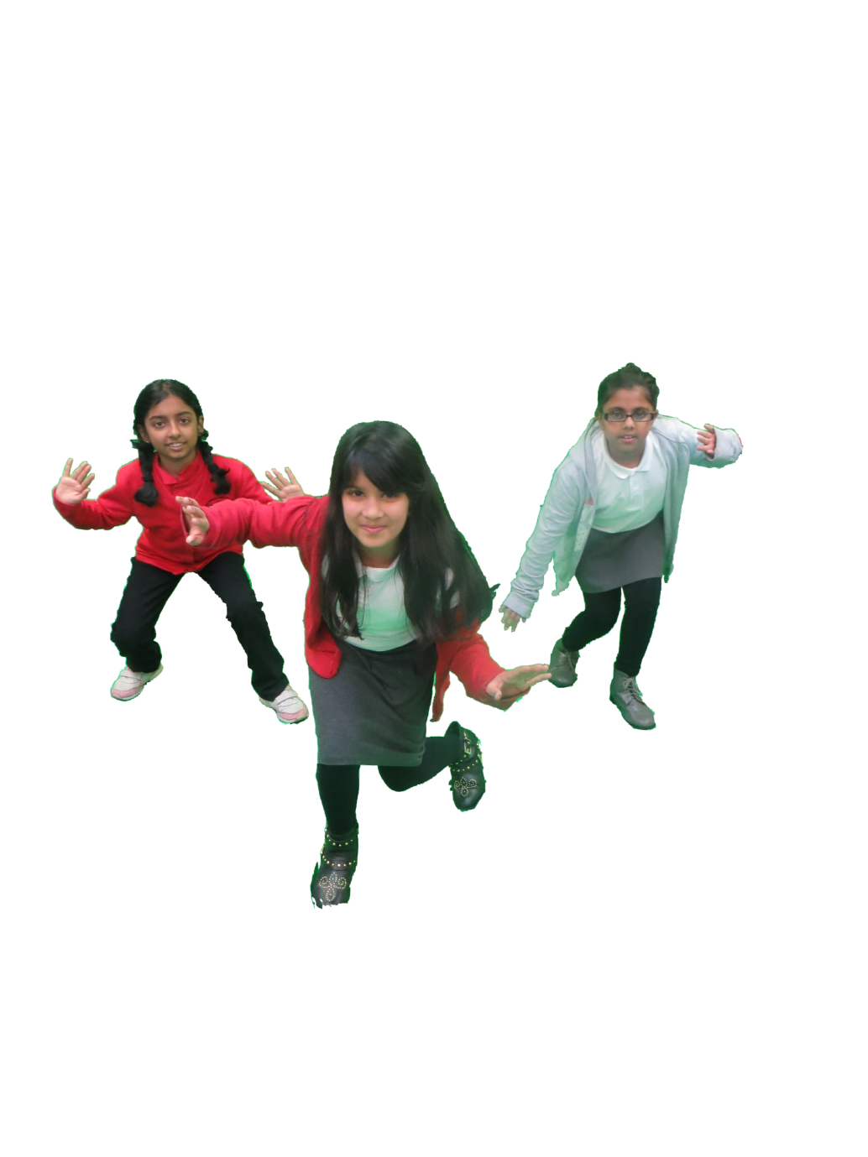

Ice skating under water. A water skating experience you will never forget!

“I will feel ecstatic with excitement because it is something I have always dreamt of doing!”

Mrs Wellington

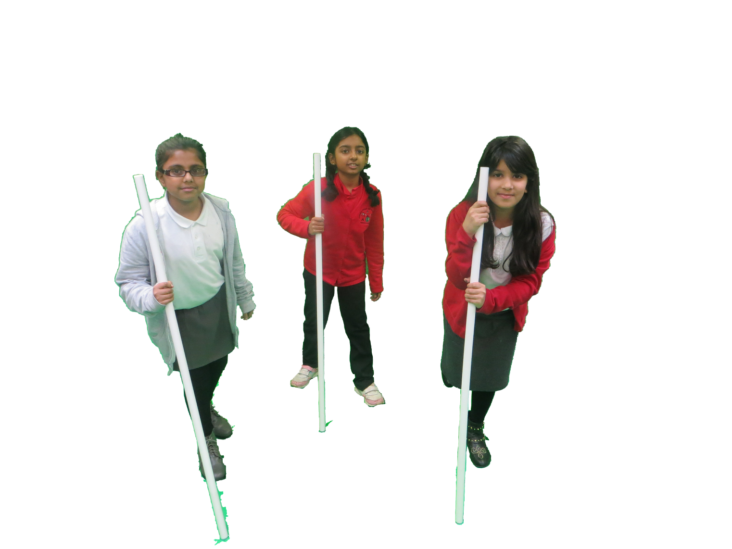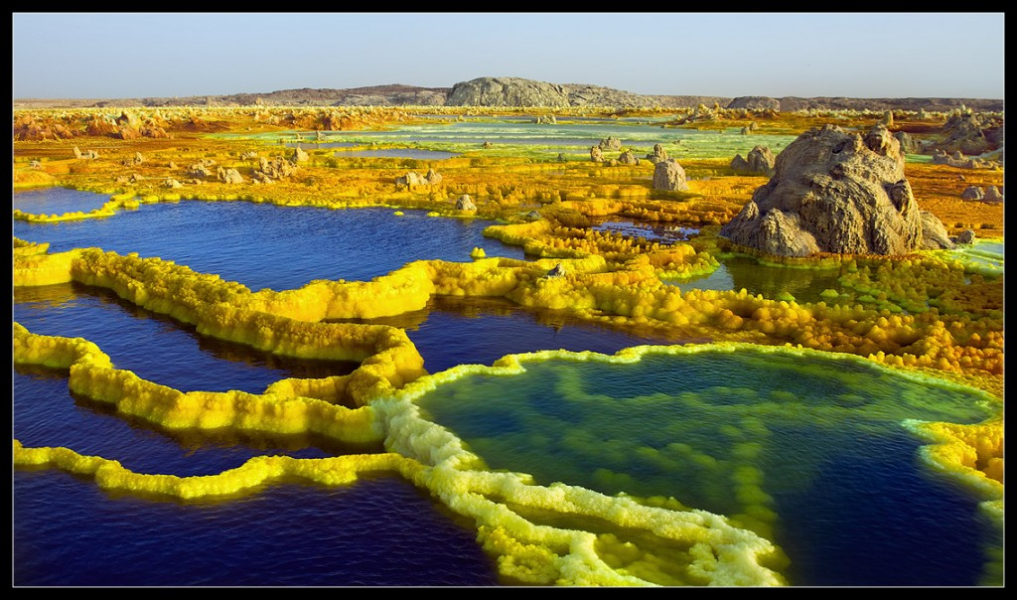

Walk on the coral. See a new world!

“I WOULD LIKE TO GO BECAUSE I’D GET SOME PEACE AND QUIET.”

Mr GARDNER

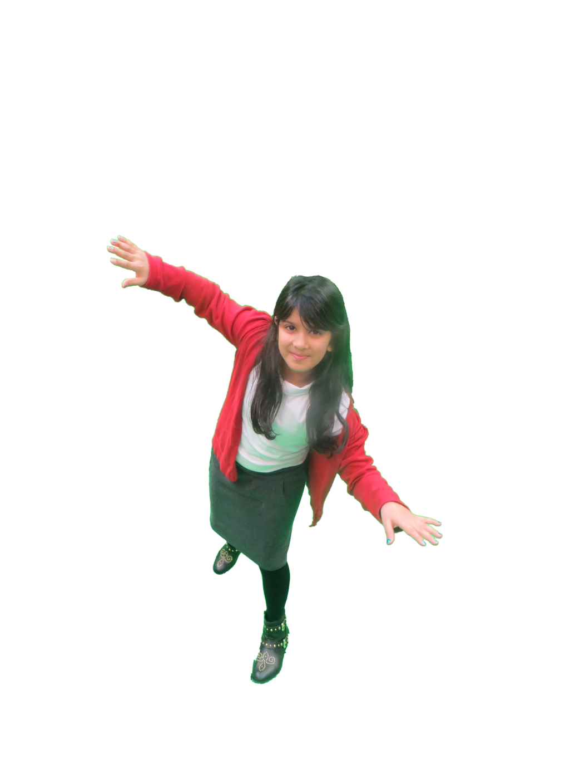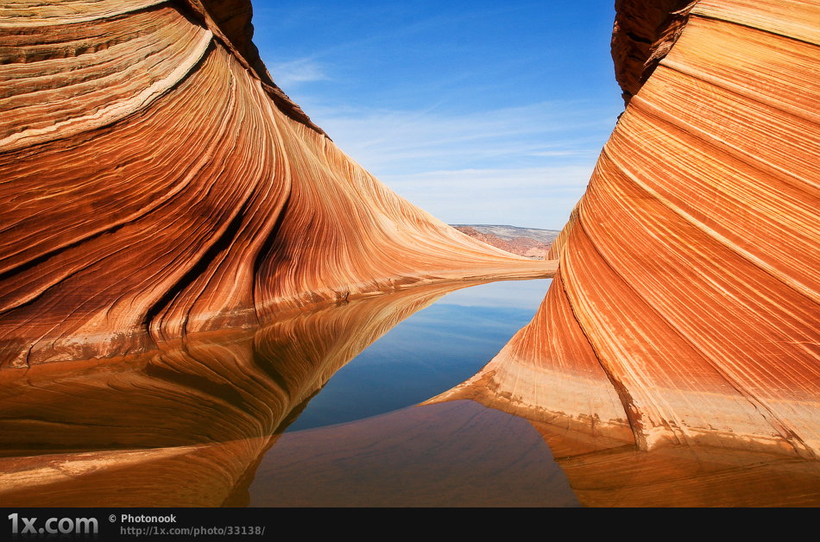M

Skydiving-fall down without getting hurt!

“I’d feel happy to experience the visit to space but at the same time I’d feel scared because I’m afraid of heights.”

Miss Broomhall

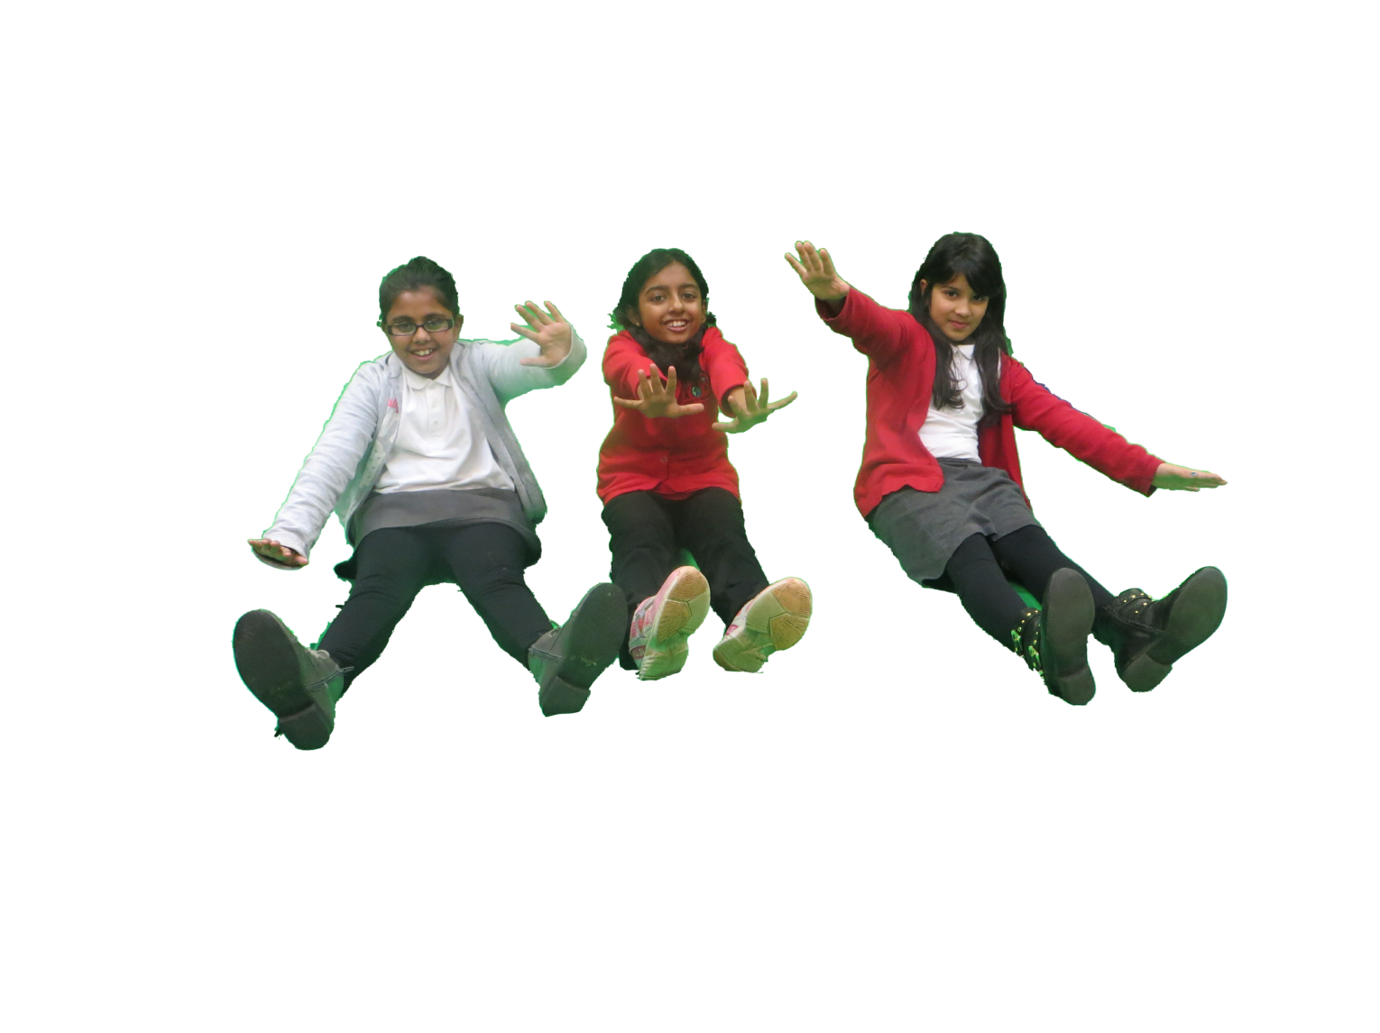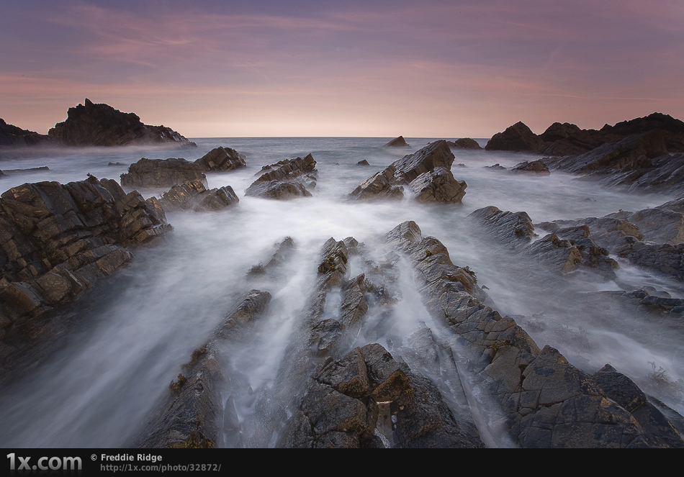M

Slide down Waterfalls! Once in a life time chance! Don’t miss this opportunity!

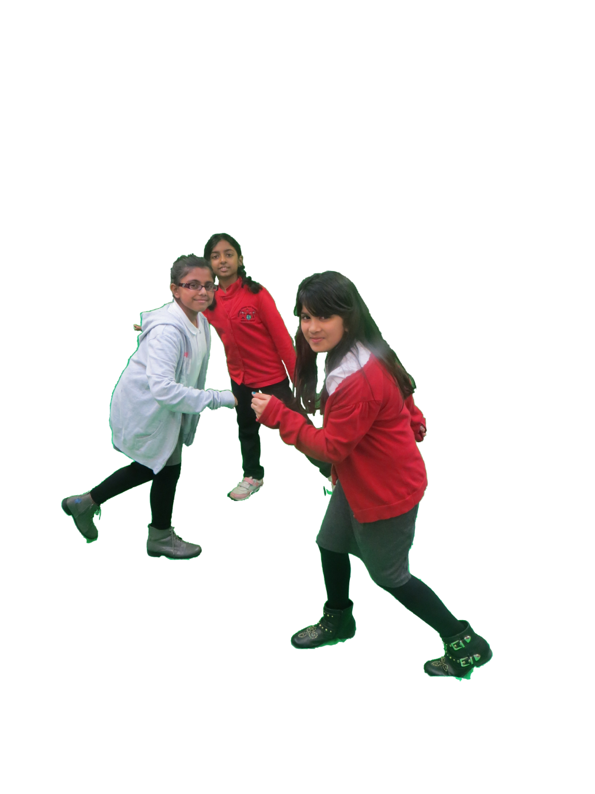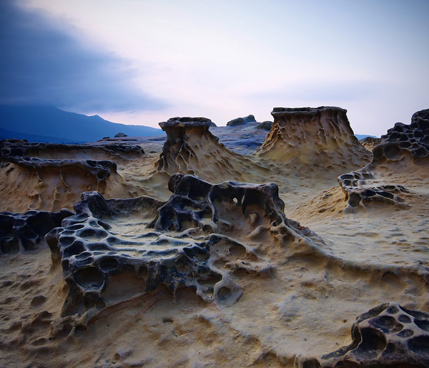M

Zero –gravity craters! SHOOT OUT OF THEM!

Experience erupting!

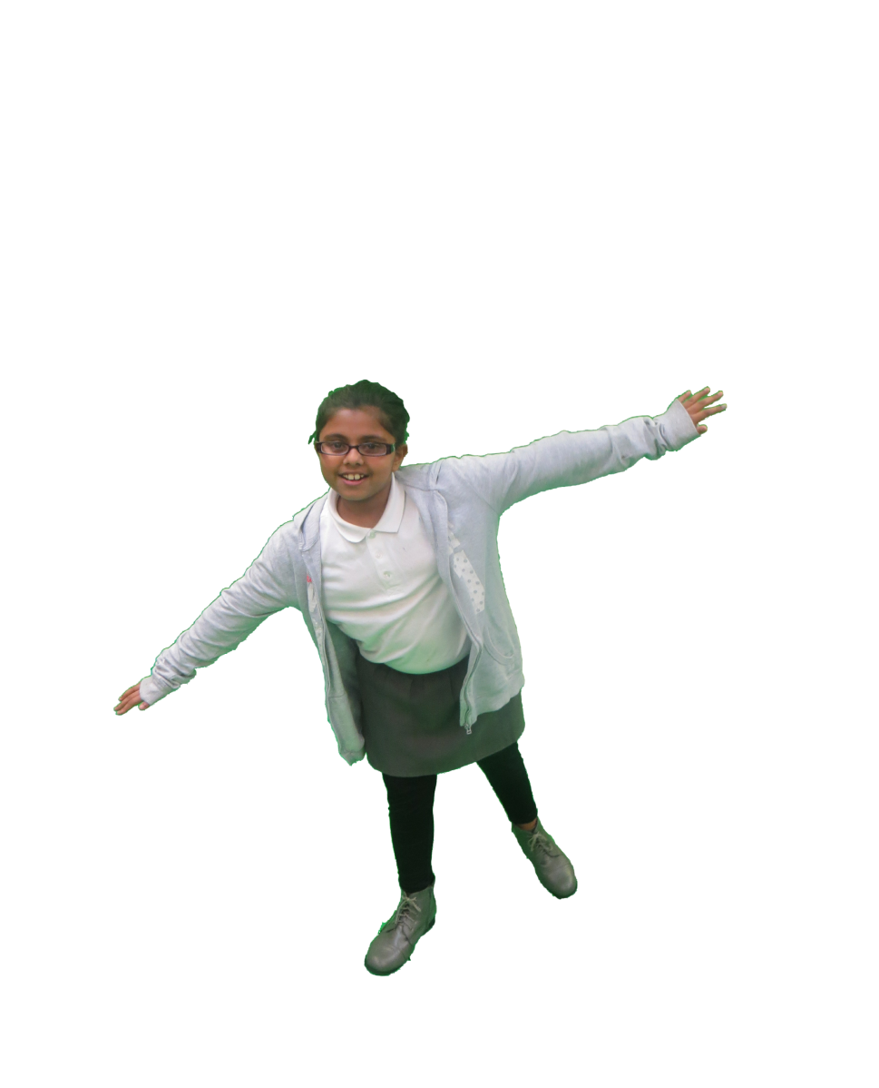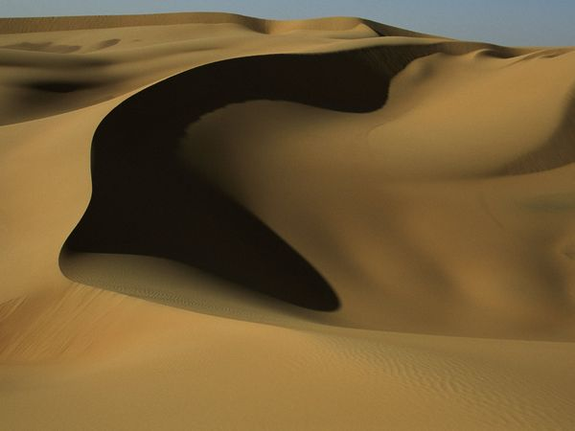M

GET CAUGHT IN A SMALL SAND STORM!

STAND IN A SAND STORM WITH OUT ANY DAMAGE.