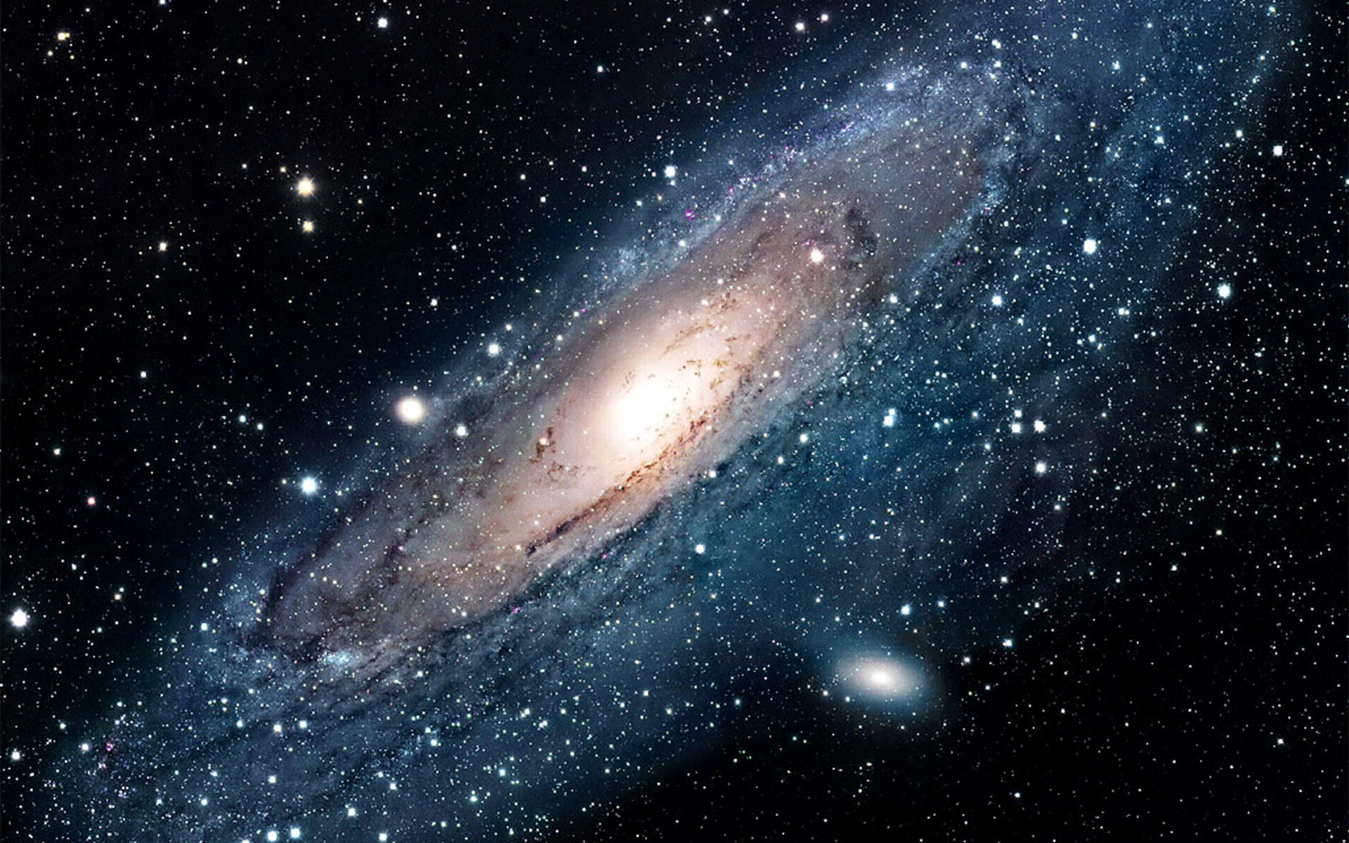

Why don’t you visit the new planet called Almonto? It has snow the colour of silver and gold. It has aquamarine water flowing from one place to another. Ice caverns have snow, which doesn’t melt. A beach that has water sprouting rocks. This planet is bubbly with smooth rocks and yellow and pink smoke. Sands, which have the colours of blue and lilac. If you love patterns, why don’t you visit the Grand Canyon? It’ll have fire and water mixing together to create a huge firework. You can have 100% freedom!
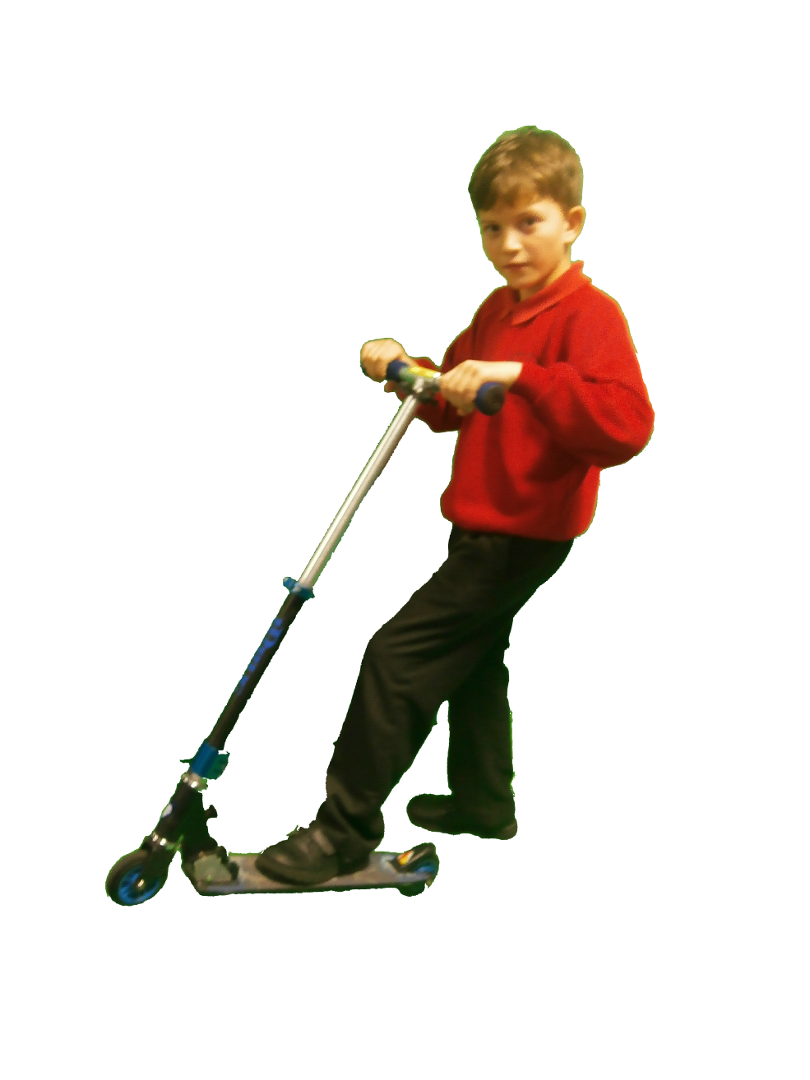
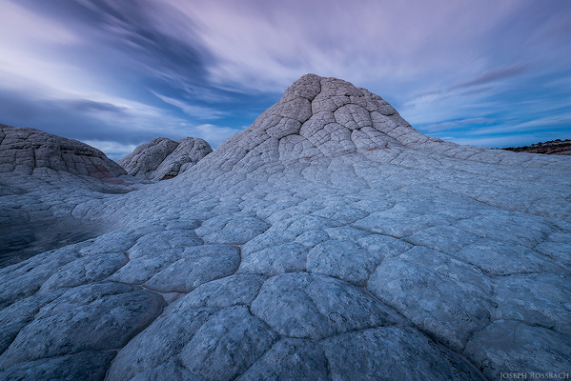
Come to our space skating park and ride over rocks.
“I would like to do space skating because it reminds me of a good memory, when I was a young child.” Mrs Ahmed

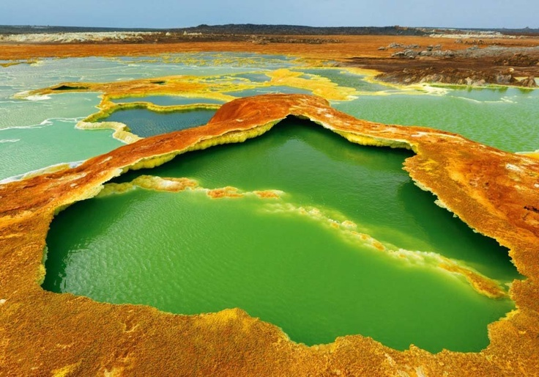
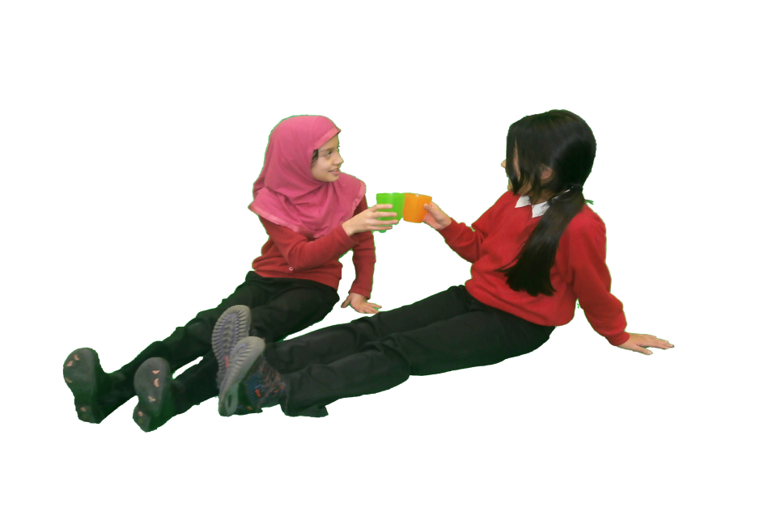
Visit the sizzling hot springs and take a sip of our latest smoothie drink, Ocean Wave.
Mrs. Houlgate: “I’ll like to go to the springs because I’d love to relax and sip a cold, relaxing drink.”

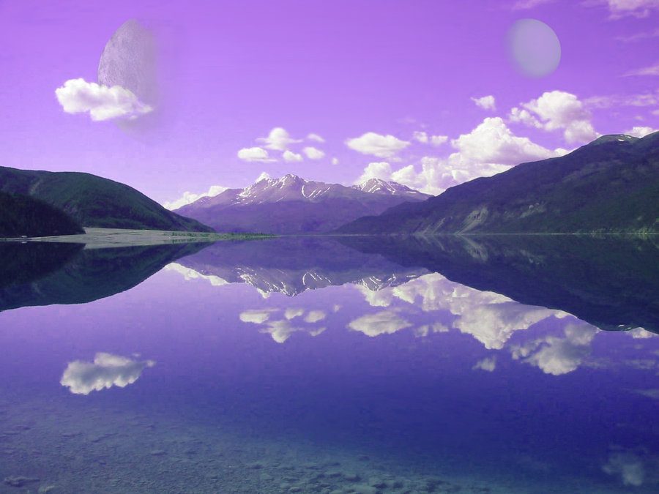
Relax and play in our best hygienic waves. Enjoy the violet water.

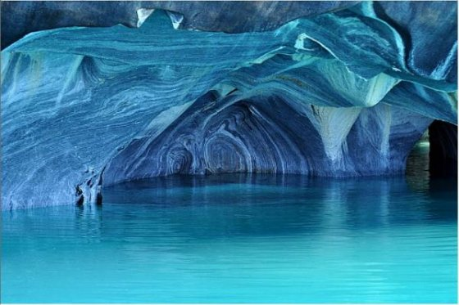
T3rwd
Come to the ice fortress and wonder through these caves forgotten in time. You can also watch an amazing water show and calm down with the beautiful surroundings, laced with frost.
Mrs Williamson: “I would like to come to the water show and see the interesting patterns!”

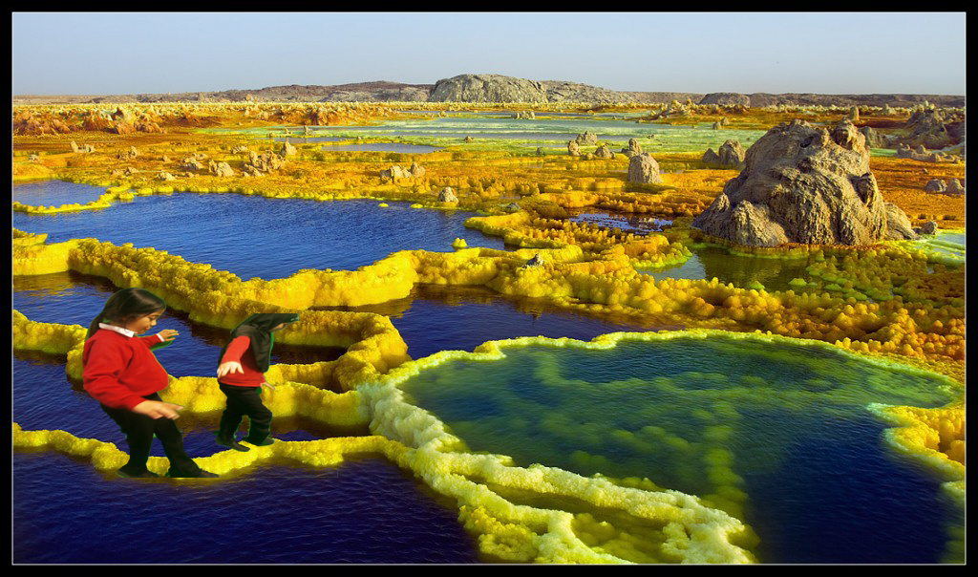
Do the impossible! Walk on the water, on our mystery lake and hear the tale of the ghost, who haunts the navy water.

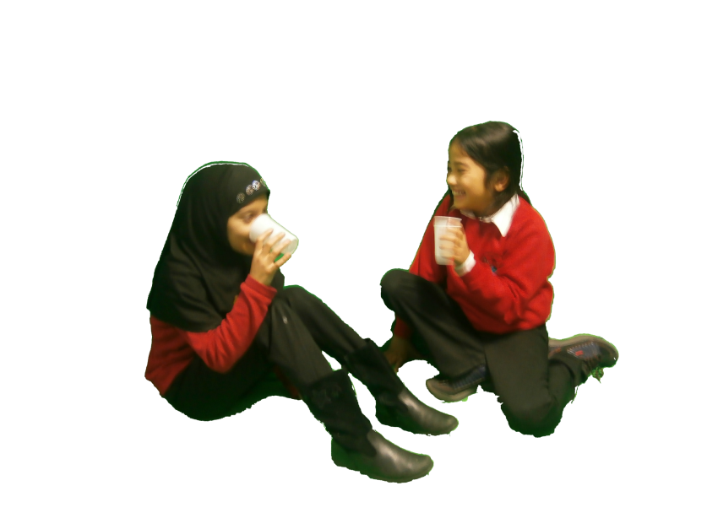
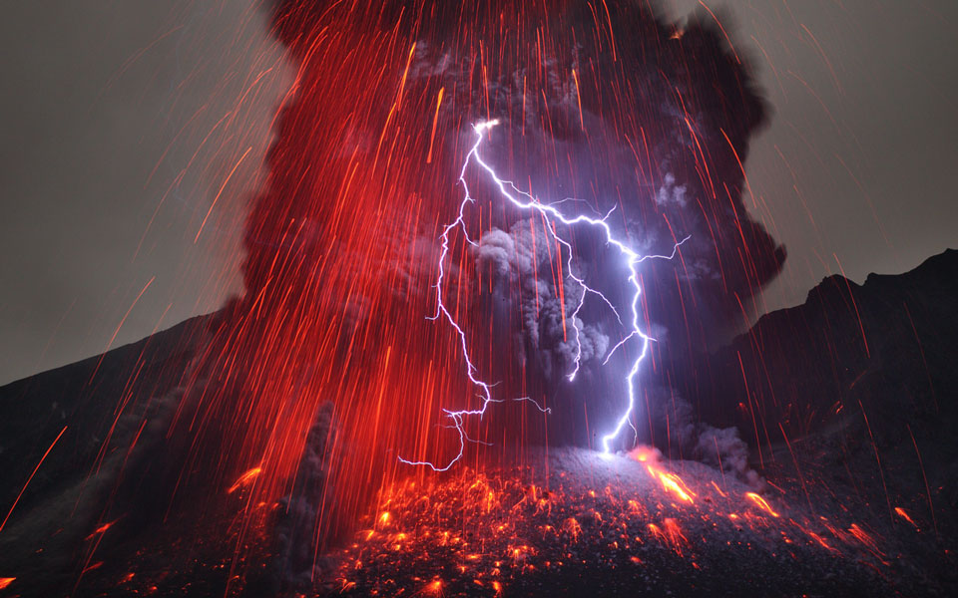
Visit the Haunted Lava Cave and see the lightning show. Drink the vanilla-scented Lava, which tastes like vanilla milkshake. Wow!

