Come to our planet, which is called the Elemental Planet of Happiness. It has lots of things you can experience.

For example it is between Mars and Jupiter. View different parts of the world. Be amazed by seeing Tyler jump off the rocks of doom at the rocky roads. Have a wonderful splash with Shannon in our relaxing pool. Run down the mystic twirly hills with Alishba.

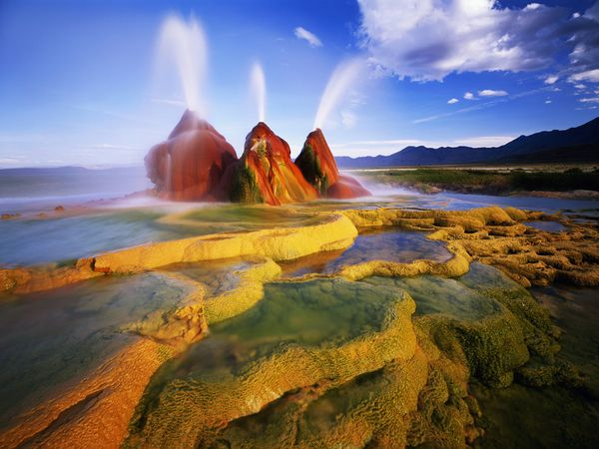

The relaxing water world

Come to this relaxing pool and see the fountains spout up in the sky. Look up and you will see a fantastic triple rainbow. (wow!)

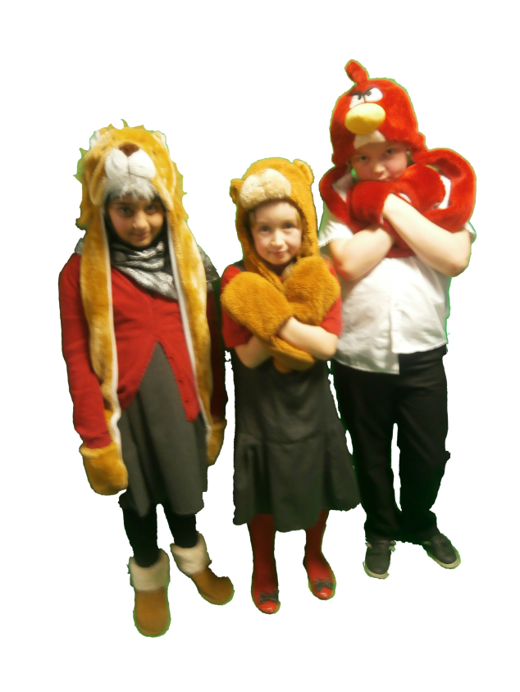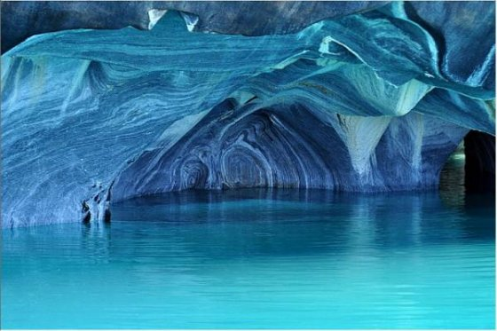

The magical ice cave

Come and see an amazing ice extravaganza. Explore the winter wonderland !

“I would like to investigate what is in the water.” Mrs Houlgate.

“I want to find out what is down there ! “ Miss Cordon.

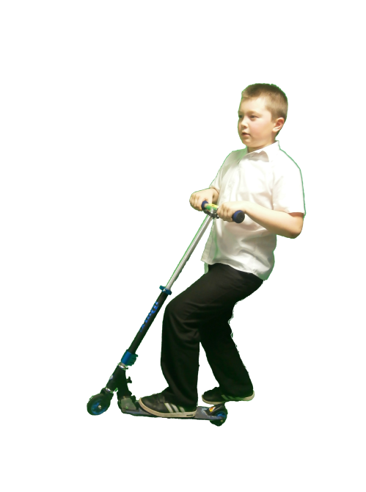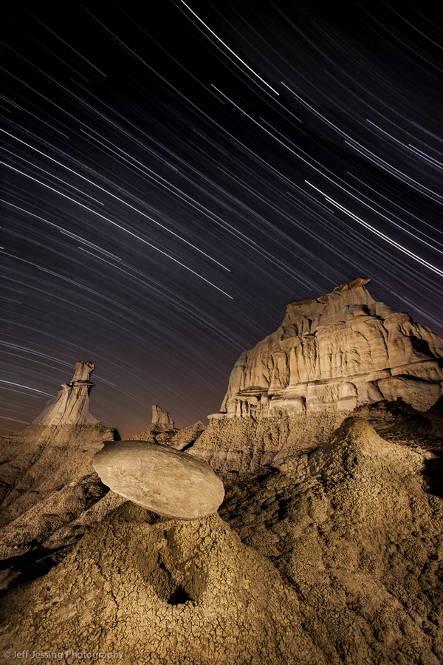

Rocky roads.

Perfect for having a fabulous time space scooting. Come and see Tyler jump off the rocks of doom!

“I would like to eat a space biscuit on the top of the rocky mountain.” Mr Gardner.



The relaxing water world

Come to this relaxing pool and see the fountains spout up in the sky. Look up and you will see a fantastic triple rainbow. (wow!)

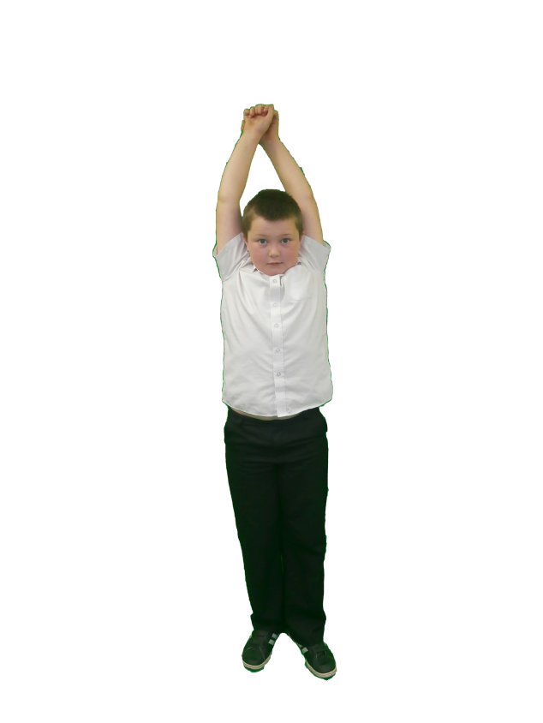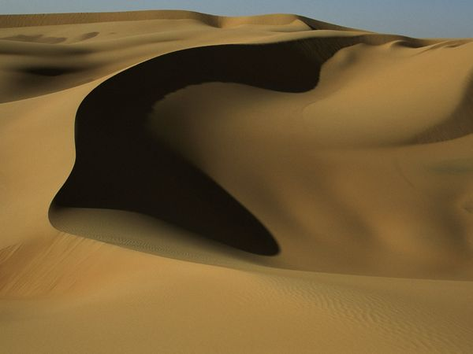

The sand slide

Enjoy the soft, smooth sandy slide,

while you brush down the hills of the desert. (This is amazing!)

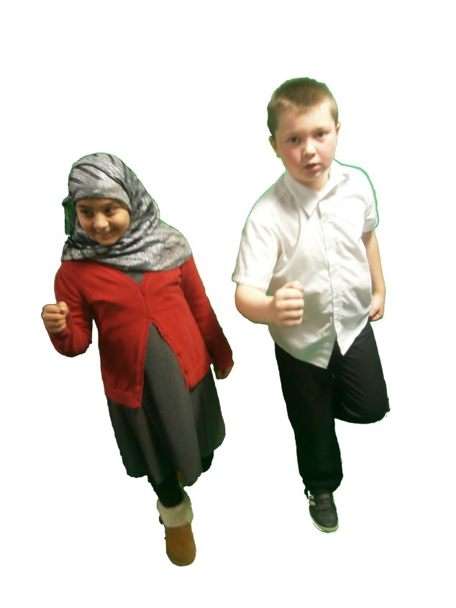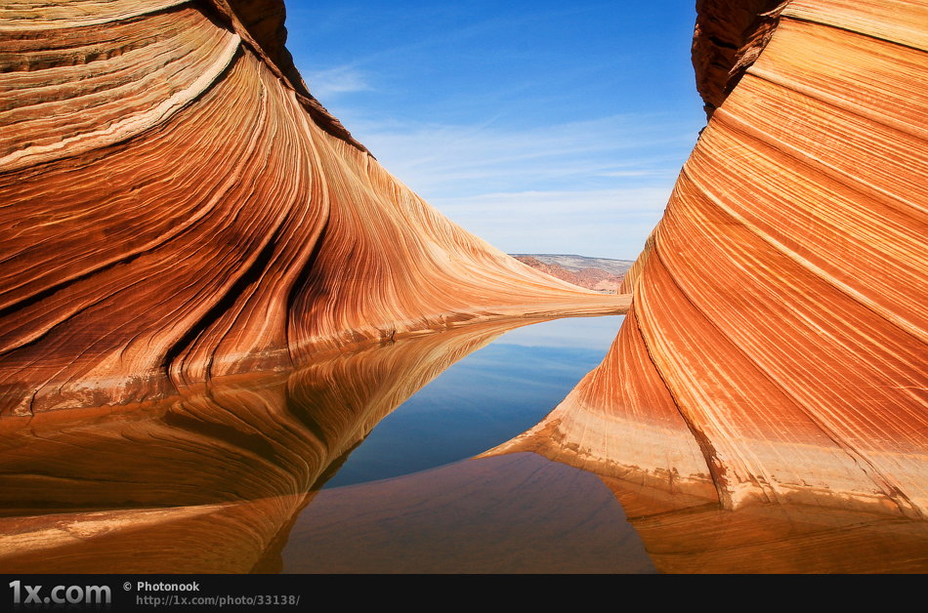

The running hills

Run down the mystic, twirly hills and enjoy a jog, while you feel the breeze sprint across your face.

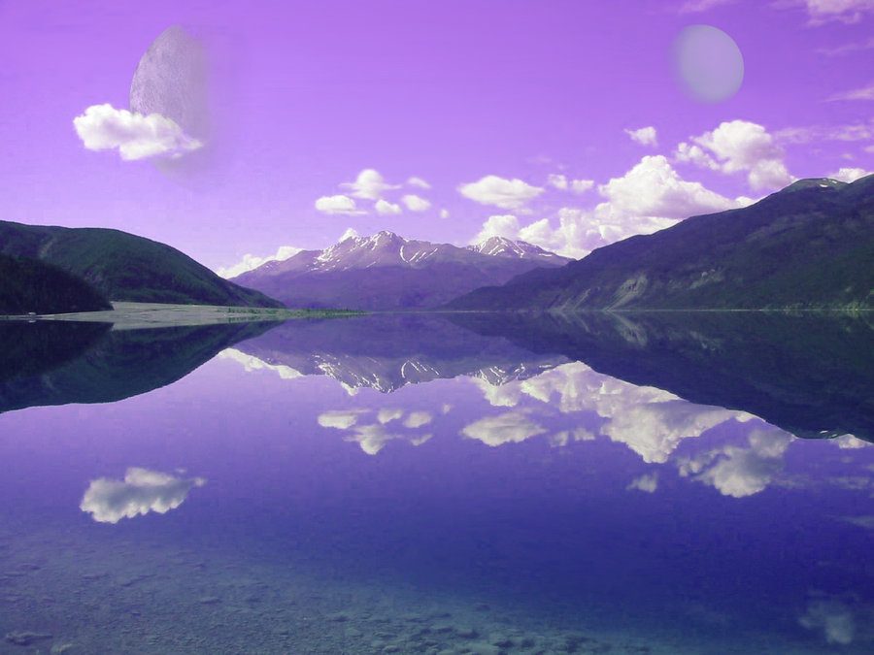

Epoh’s lake

Have a dive in the lake and see the birds fly past while you swim. Also at the weekend you can ride a happy, beautiful dolphin. (up down up down weeeeeeeeeeeeeeee!)