The School Attendance Team

Mr C Hollis (Attendance Lead)
Mrs R Akhtar (Parent Support Worker)
Our Office Administrator
Your child’s class teacher
and all members of the school Senior Leadership Team (Ms K Hall, Mr S Hall, Miss L Bowden and Mr D Grimshaw)
and


For more information, you can either look on the attendance page on our school website or contact one of the team to make an appointment in school, where we will answer your questions and concerns.

Thank you – together we can achieve great things
SEPTEMBER is ATTENDANCE AWARENESS MONTH
Our New Approach to Attendance and Absence
For every child to succeed in school, we know that every day counts!
Together as a partnership, both school and home can make this happen for our children.

“Attendance Mice, give good advice
Be in School!”



Meet Merv and Meena Mouse, our Attendance Mice


Merv says,
‘’We are the best Attendance Team!”
Meena worries about what will happen to children who are persistently absent.

A more Inclusive and Supportive Attendance Approach 2025/26
We are delighted to share important updates regarding our approach to attendance at Scotholme Primary School. Our commitment to providing the best support for our children and families has led us to collaborate with an organisation known as Inclusive Attendance, as well as our on-going partnership with Nottingham City Local Authority. Together, we aim to empower children to attend school regularly and overcome any barriers that may be preventing this.
Our new approach is based upon an inclusive attendance model to ensure that everyone – staff, children, families and other agencies fully understand their roles and responsibilities in supporting school attendance, being actively engaged and addressing potential barriers.



Did you know?
In 2024, 83.9% of children who attended regularly met the expected standards (EXS), whereas ONLY 40.2% of children who were persistent absentees hit the same standard.

Of the higher standard, 21.8% of children who attended regularly reached the GDS standard, whereas ONLY 2.5% of persistent absentees did.

Children who are ‘not school ready’ at age 5 are at a higher risk of future absenteeism.

Children who become a persistent absentee one year are more likely to repeat this over several years, unless there is an intervention.

Days missed not percentages
Effective communication with our families is central to our values at Scotholme Primary. Considering this, we will change from reporting attendance in percentages to a focus on the number of days missed. This shift will simplify the process, enhance communication and help everyone have a clear understanding of the impact of missed school days on education.
Days absent | Previous Percentage | Risk of becoming a persistent absentee (PA) | School Approach
0 | 100 | No risk of PA
1 |  | Low (Risk Of PA)
2 |  | Low (Risk Of PA)
3 |  | Low (Risk Of PA)
4 |  | Low (Risk Of PA)
5 | 97.4% | Low (Risk Of PA) | Letter 1 sent
6 |  | Low (Risk Of PA)
7 |  | Low (Risk Of PA)
8 |  | Low (Risk Of PA)
9 |  | Low (Risk Of PA)
10 | 94.7% | Moderate (Risk Of PA) | Letter 2 sent and invite to a meeting
11 |  | Moderate (Risk Of PA)
12 |  | Moderate (Risk Of PA)
13 |  | Moderate (Risk Of PA)
14 |  | Moderate (Risk Of PA)
15 | 92% | High (Risk of PA)
16 |  | High (Risk of PA)
17 |  | High (Risk of PA)
18 |  | High (Risk of PA)
19 + more | 89.5% | Persistent Absentee

Why is being a Persistent Absentee an issue for your child?

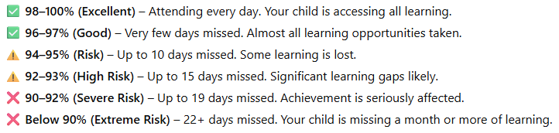

when children miss school often, it can cause some challenges for them:
💡 They can find learning harder – Lessons build on each other, so missing school means they may struggle to keep up.
💡 Friendships can be affected – Being away a lot makes it harder for children to feel part of the class and enjoy time with friends.
💡 Routines get disrupted – Regular attendance helps children feel secure and confident in their daily routine.
💡 They may fall behind long-term – Missing lots of school now can make it harder to achieve their very best in the future.
💡 We worry about them – If we don’t hear from you about why your child is absent, we will need to follow up, as it’s part of keeping all children safe.

Tier
Tier 2

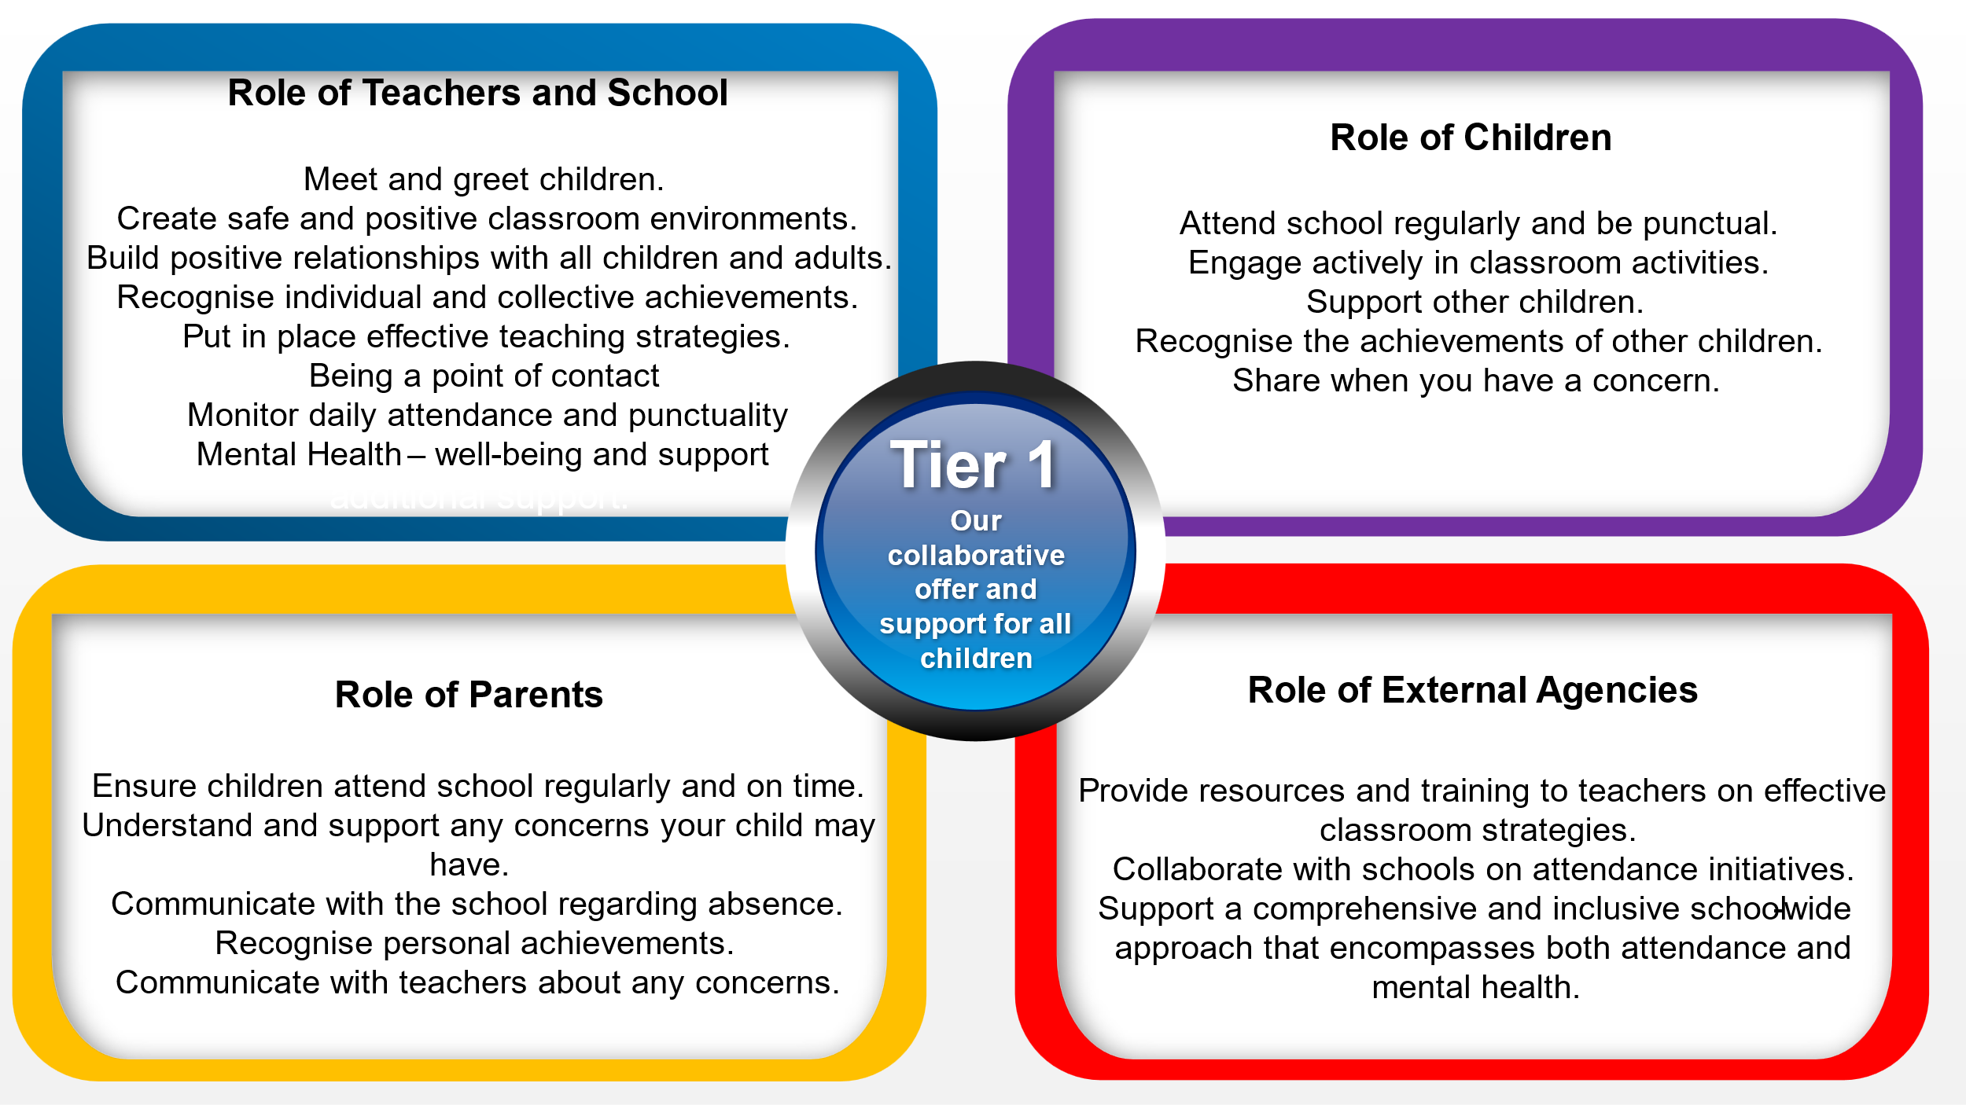
Tier 2 – Support offered where children are at risk of becoming a persistent absentee (between 14 and 18 days of absence)
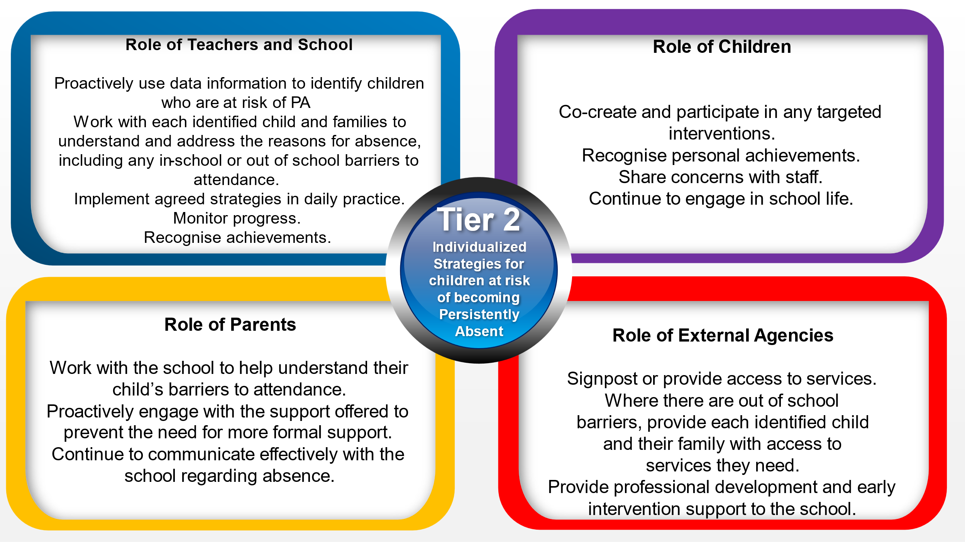
Tier 3- Support for children who are already Persistent Absentees
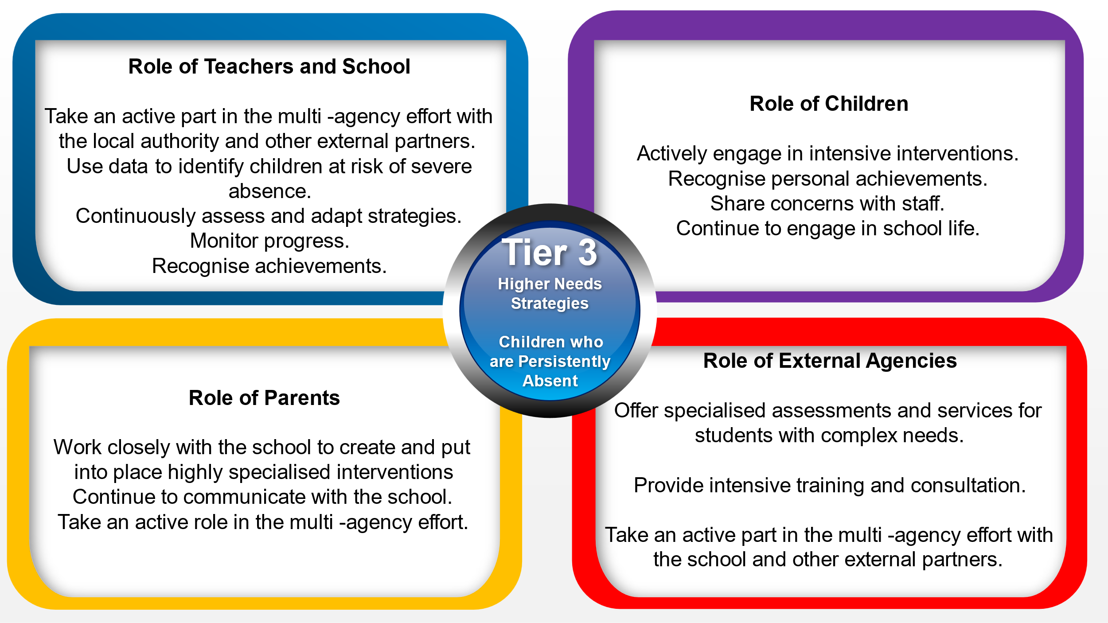
Three-tiered Approach
To achieve this, we will be introducing a multi-tiered system of support that caters for the needs of individual children. It starts with Tier 1 – support for all children. Tier 2 provides additional support for some children with the help of early help services and finally Tier 3, where we ensure that certain families have access to specialised support.
The following diagrams explains the roles and support offered at each level: -
Tier 1 – Universal support – what we expect for everyone

